Provider:
Surname:
Forename:
CHILD DETAILS

Preferred Surname:
Middle Names:
Provider: Has evidence of DOB been seen? E.g. birth certificate, please tick
DOB: _ _ / _ _ / _ _ _ _
Address:

Gender: M / F / Not Known / Not Specified
2 Year Old ID: _ _ _ _ _ _ _ _ _ _ _
Postcode:
If yes, please circle: SEN Support / Education, Health and Care Plan
SEN Provision: Y / N
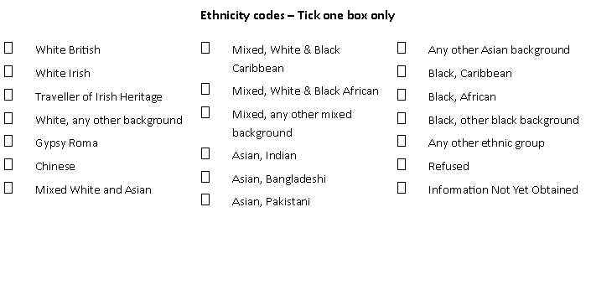

PARENT DETAILS
You must confirm your eligibility to access the 30 hours entitlement with HMRC every 3 months through Childcare Choices.
To receive funding for 30 hours / EYPP please fill out the parent/carer details below:

Parent/carer 2 name:
Parent/carer 1 name:

Parent/carer 2 National Insurance No: _ _ _ _ _ _ _ _
Parent/carer 1 National Insurance No: _ _ _ _ _ _ _ _ _ _
Parent/carer 2 DOB: _ _ / _ _ / _ _ _ _
Parent/carer 1 DOB: _ _ / _ _ / _ _ _ _
Parent/carer 2 NASS (if applicable): _ _ _ _ _ _ _ _ _ _
Parent/carer 1 NASS (if applicable): _ _ _ _ _ _ _ _ _ _

30 Hour eligibility code: _ _ _ _ _ _ _ _ _ _ _ _ _ _ _
30 Hour eligibility code: _ _ _ _ _ _ _ _ _ _ _ _ _ _ _

Names of all childcare providers currently used (please enter in universal and extended hours on different rows for each provider) | Please enter total funded entitlement hours claimed per week at each setting |  | Total number of hours claimed per week | Stretched offer?  Tick against ALL settings this applies to.
 | Universal Hours | Extended Hours
Provider 1:  e.g. Lily pad childcare | 15 |  | 15
Provider 2:  e.g. Brown Owl Nursery |  | 15 | 15
Name and Signature:
Funding end date (if known): _ _ / _ _ / _ _ _ _
Funding start date: _ _ / _ _ / _ _ _ _
FUNDING DETAILS
Please multiply the total number of hours claimed per week by the number of weeks you are accessing per year. Standard offer is 38 weeks (term time only) and stretched offer is a reduced number of hours delivered over more than 38 weeks per year. Universal hours must not exceed 570 hours over the year. Universal and extended hours must not exceed 1140 over the year. E.g. 15 hours x 38 weeks = 570 hours / 30 hours x 38 weeks = 1140

Total un-funded hours per week (these are the hours the parent is required to pay for): _ _ _ _
Parent note: If the child is attending another setting, you must add the details in the provider 2 section.

Provider note: If the number of hours per week changes, providers must amend this form, ask the parent to re-sign and date the form and state the date when the change happened

DISABILITY ACCESS FUNDING (DAF) 3 and 4 year olds only

Is this child in receipt of disability living allowance: Y / N
Provider note: If the child is in receipt of DLA has a certificate been uploaded onto the EY Hub and the DAF question changed to 'Yes'?
Do you nominate this provider to receive DAF? Y / N
You may nominate one provider to receive DAF.

SIGNATURES

By signing this form, parents/carers agree for their data to be shared with the Local Authority and record the child details on the Children's Centre register. If you do not wish for your details to be registered at the Children's Centre, please tick here:

I declare that all information on this declaration form is true to the best of my knowledge. I understand that any false or incorrect information could lead to funding being withdrawn or reclaimed. Please be aware that to certify false information could be viewed as making a fraudulent claim. By completing the parent details section of this form I am giving permission to check for DAF, EYPP and 30 hours funding.

Date: _ _ / _ _ / _ _ _ _
Name and Signature:
Please note, we are committed to collecting and processing your personal data in a fair and transparent manner. For more information about how we use your personal details please see our Privacy Notice here: https://www.lincolnshire.gov.uk/eycc/early-years-entitlements/registration-and-delivery/129305.article

